

"Just Walk Out" Technology

By Amazon

TRACK 1: BUSINESS ANALYTICS & IT MANAGEMENT related AI

TEAM: ErebeForge

From

B.Sc. AIML (1st year)

Sec: A

# Overview

* "Just Walk Out" technology is a unique never been done before solution by Amazon which eliminates the need of a cashier in its Amazon Fresh and Amazon Go places of business. The process utilizes AI, computer vision, sensor fusion and deep learning technology to track customers movements, enabling them to operate without traditional checkout lines.

## Key Components of "Just Walk Out" Technology

* **Computer Vision**: Opposed viewpoints are potentially detected using computer vision. The Shop will be monitored incessantly using video footage. The movements and behavioral patterns of customers in relation to the products placed on the racks are recorded and tracked with these cameras. Advanced couplings are made that utilize such video streams to know who picked which product, and at what time.
* **Sensor Fusion**: In order to determine when an object is lifted or replaced to the shelving unit, weight sensors are added in the shelves. These sensors are used along with the computer vision system to know with precision the time that an item is removed or replaced on the shelf.
* **Deep Learning**: The technology uses deep learning models, which gather knowledge throughout their operational use and integrate that knowledge into their further processing. This mostly entails the recognition of tendencies in customer behaviors, the recognition of products, and movement patterns inside the store.
* **RFID and IoT Integration**: Most products come embedded with RFID tags that help in focusing on what they have selected. In addition, the combination of IoT devices inside the perimeter of the store allows seamless transmission of real time data and communication between different kinds of sensors and cameras with the backend system.
* **Customer Mobile App Integration:** Customer app is integrated with the Amazon technology. As customers walk into the store, they avail of a feature available on the app that allows them to scan a QR code to commence their shopping session.

## How it’s Work?

* **Entry**: A visitor enters a store by scanning a QR code displayed at the gate with their Amazon app. The gate opens and logs in the customer and the system.
* **Shopping**: While customers are walking around and grabbing products, a set of cameras and sensors in combination with an application also capture and store a record of how many and which products a customer has taken. If a customer returns an item to the shelf, that fact is also recorded by the system.
* **Exit**: When customers are done shopping, they just walk out of the shop. There is no process of checking out. There is a system in place that deducts the cost of goods taken from the customers’ Amazon accounts.
* **Receipt**: Once a customer has made purchases through the App as Payment, he/she receives a receipt to their App indicating what items have been purchased, costs of the items, available discounts and any marketing campaigns undertaken.

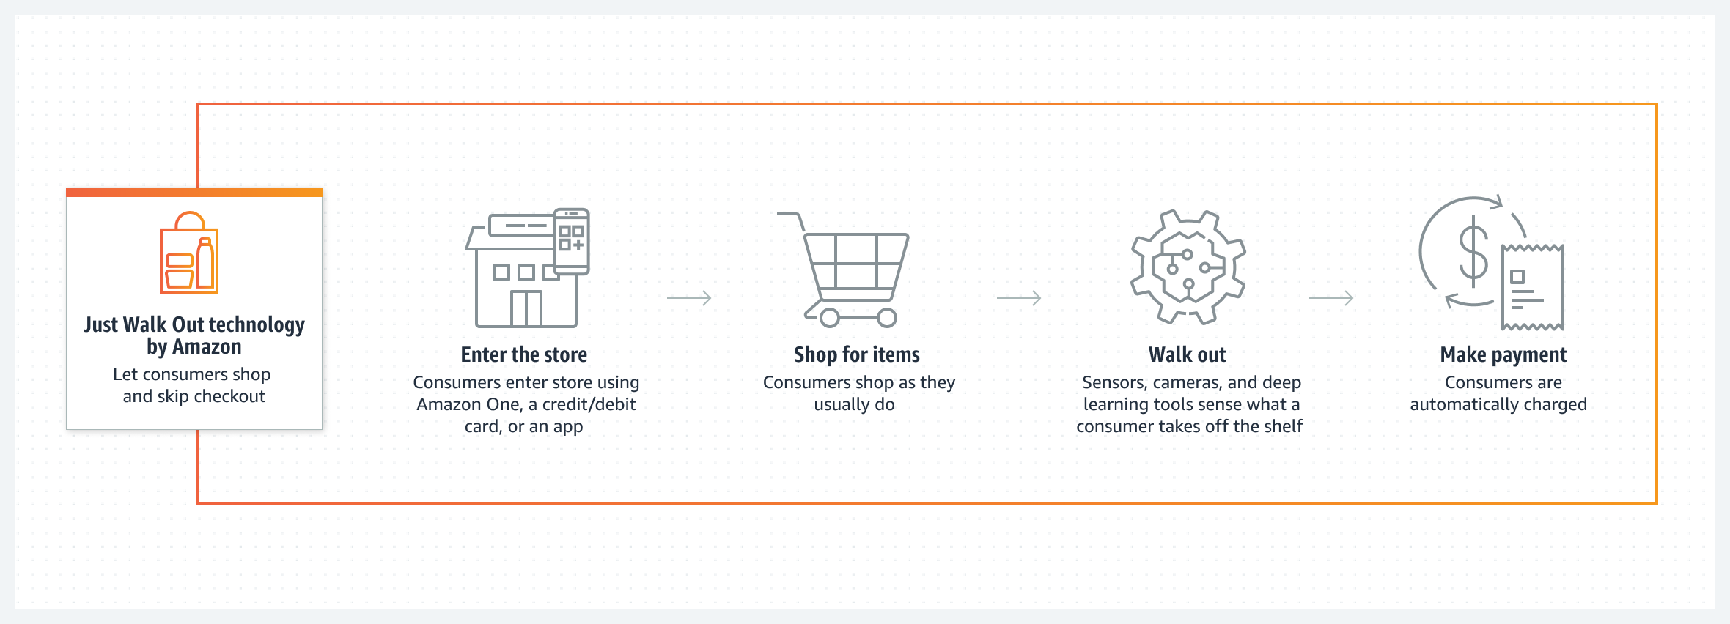

## Challenges and Considerations

* **Privacy Concerns**: As one may consider the presence of cameras or tracking, these technologies exude some privacy concerns. Customers may be uncomfortable with the manner in which Amazon collects, stores, and utilizes their information.
* **High Initial Costs**: There is a very high initial cost involved in the procurement of assets like hardware (cameras, sensors, etc.) Software, and system integration that is required to roll out the “Just Walk Out” technology which may be unavailable in many retail settings.
* **Technical Limitations**: The technology might get problems if an area is designed in a complex manner, experiences a lot of traffic, or products are placed haphazardly. Errors in the detection or identification of products can bring disturbance toward customers.
* **Limited Compatibility**: Companies do not apply current technologies to track all products. For example, those assisting mature shoppers with the purchases of fruits may involve a moveless camera that does not sense the items.

## Technical Disadvantages

**Recognition Errors**:

* **Issue**: Sometimes, the system might get confused by products that look alike or struggle when there are lots of people around. This can lead to mistakes in charging customers.
* **Impact**: Customers might end up with incorrect charges, which can be frustrating and lead to complaints.

**Scalability Issues**:

* **Issue**: Expanding this technology to larger stores means adding more cameras, sensors, and computing power. This can make the setup more complex and expensive.
* **Impact**: Growing the technology to accommodate bigger spaces or more locations can become costly and challenging to manage.

**Hardware Limitations**:

* **Issue**: The system relies on advanced sensors and cameras, which can sometimes break down or need regular maintenance to keep working properly.
* **Impact**: Hardware issues can disrupt the system’s accuracy and lead to higher maintenance costs.

**Dependency on Internet**:

* **Issue**: The technology needs a constant internet connection to function correctly. Any interruptions or slowdowns in connectivity can affect how well the system works.
* **Impact**: If the internet goes down or slows down, it can cause problems with how the technology operates.

**Integration Challenges**:

* **Issue**: Making sure the technology works well with existing store systems can be tricky, especially for items that are loose or not packaged. This might require extra manual handling or adjustments.
* **Impact**: It can complicate the integration process and might need more effort to fit into current store operations.

**Energy Consumption**:

* **Issue**: The technology uses a lot of power for its sensors and data processing.
* **Impact**: This can increase the store’s energy bills and raise concerns about environmental impact.

**Need for Constant Updates**:

* **Issue**: The AI models need regular updates to keep up with new products and changes in the store layout.
* **Impact**: Keeping everything up-to-date can be demanding and requires ongoing effort and resources.

## solution for Technical Disadvantages

**Improve Recognition Accuracy**:

* **Solution**: Enhance the system’s AI by using better training techniques and combining different types of sensors, like depth sensors, to make product recognition more accurate.
* **Impact**: This helps reduce errors and ensures customers are charged correctly.

**Enhance Scalability**:

* **Solution**: Use edge computing to handle data processing locally and create modular systems that can be adjusted based on store size.
* **Impact**: This makes it easier and more cost-effective to expand the technology to larger or multiple stores.

**Boost Hardware Reliability**:

* **Solution**: Implement backup systems and establish regular maintenance routines to keep sensors and cameras in good working condition.
* **Impact**: This minimizes hardware failures and keeps the system running smoothly.

**Reduce Internet Dependency**:

* **Solution**: Incorporate local data storage and set up reliable backup networks to keep the system operational even if the internet connection has issues.
* **Impact**: This helps ensure that the technology continues to work seamlessly, even during connectivity problems.

**Facilitate Integration**:

* **Solution**: Develop APIs and use technologies like RFID and IoT to make the technology compatible with existing retail systems.
* **Impact**: This simplifies the integration process and helps the technology fit into current store operations more easily.

**Improve Energy Efficiency**:

* **Solution**: Use energy-efficient hardware and implement power management strategies that adjust energy use based on demand.
* **Impact**: This reduces energy consumption and helps cut down operational costs.

**Optimize AI Model Updates**:

* **Solution**: Adopt continuous learning techniques and automated data labeling to keep the AI models updated with minimal manual intervention.
* **Impact**: This ensures the AI remains accurate and effective with less effort and resource expenditure.

## Real-World Applications

**Amazon Go Stores**:

* Amazon Go was the pioneer for "Just Walk Out" technology, launching its first store in Seattle back in 2018. Since then, the concept has expanded to over 20 locations across the U.S.

**Amazon Fresh Stores**:

* Amazon Fresh has taken the technology to a larger scale with its grocery stores. The first "Just Walk Out" Amazon Fresh store opened in Woodland Hills, California, in 2020.

**Licensing to Third Parties**:

* Amazon is now offering its "Just Walk Out" technology to other businesses, including airport shops and stadium stores.

## Future Outlook

Looking ahead, "Just Walk Out" technology hints at a future where cashier-less stores might become the norm. This technology has the potential to transform how we shop by making the experience quicker and more streamlined, without the hassle of traditional checkout lines.

As the technology evolves, we can anticipate several exciting developments:

* **Greater Accuracy**: We’ll likely see improvements that reduce recognition errors, making the system even more reliable.
* **Lower Costs**: Over time, the technology could become more affordable, making it accessible to a broader range of retailers.
* **Better Integration**: Future advancements may allow "Just Walk Out" technology to work seamlessly with other retail innovations, creating a more connected shopping experience.

Overall, as this technology becomes more refined, it could reshape the retail world, offering a faster and more efficient way to shop while providing valuable data to enhance the shopping experience.

## Conclusion

"Just Walk Out" technology represents a significant leap forward in the retail sector, offering a glimpse into a future where shopping is simpler and more efficient. By eliminating traditional checkout processes, this technology streamlines the shopping experience, allowing customers to enter, pick up what they need, and leave without the hassle of waiting in line.

**Key Takeaways:**

* **Innovation in Convenience**: The technology provides a more convenient shopping experience, catering to the growing demand for speed and efficiency in retail.
* **Challenges and Opportunities**: While it offers many benefits, there are challenges such as recognition errors, scalability issues, and the need for constant updates. However, these challenges also present opportunities for innovation and improvement.
* **Future Potential**: As the technology continues to evolve, we can expect advancements in accuracy, cost-effectiveness, and integration with other retail systems. This will likely lead to wider adoption and potentially redefine the shopping landscape.

## references

News Articles and Media Coverage

* **Bloomberg**
* **Wired**
* **CNBC**

[AMAZON GO](https://www.amazon.com/b?node=16008589011)

Academic and Technical Papers

* **Google Scholar**:
* **SpringerLink**: